SALESFORCE FIELDS AND RELATIONSHIPS DOCUMENTATION
Courier Management System
This document defines the recommended custom fields and object relationships for the Salesforce Courier Management System. It also includes setup steps, verification checks, and evidence spaces for screenshots taken from Salesforce.

1. How to Create a Field in Salesforce
1. Open Setup.
2. Open Object Manager.
3. Select the required object.
4. Select Fields & Relationships.
5. Click New.
6. Choose the required data type and click Next.
7. Enter the Field Label and other settings.
8. Configure required, unique, default value, picklist values, or relationship settings as needed.
9. Set field-level security.
10. Add the field to the required page layout.
11. Click Save.

2. Recommended Fields

2.1 Customer Fields
Salesforce Object API Name: Customer__c
Field Label | API Name | Data Type | Required | Constraint / Values | Purpose
Customer Name | Name | Text (standard) | Yes | Standard Name field | Stores the customer name.
Email | Email__c | Email | Yes | Valid email format | Stores the customer's email address.
Phone | Phone__c | Phone | Yes | Phone number | Stores contact number.
Address | Address__c | Long Text Area | Yes | 255+ characters as required | Stores street/address details.
City | City__c | Text(80) | Yes | - | Stores city.
State | State__c | Text(80) | Yes | - | Stores state.
Postal Code | Postal_Code__c | Text(20) | Yes | - | Stores PIN/postal code.

2.2 Shipment Fields
Salesforce Object API Name: Shipment__c
Field Label | API Name | Data Type | Required | Constraint / Values | Purpose
Tracking Number | Tracking_Number__c | Auto Number | Yes | Format: SHP-{0000} | Unique shipment tracking reference.
Customer | Customer__c | Lookup(Customer) | Yes | Relationship field | Links shipment to the customer.
Origin Branch | Origin_Branch__c | Lookup(Branch) | Yes | Relationship field | Branch where shipment starts.
Destination Branch | Destination_Branch__c | Lookup(Branch) | Yes | Relationship field | Branch responsible for destination.
Assigned Delivery Agent | Assigned_Delivery_Agent__c | Lookup(Delivery Agent) | No | Relationship field | Agent assigned for delivery.
Shipment Date | Shipment_Date__c | Date | Yes | - | Date shipment was created/dispatched.
Expected Delivery Date | Expected_Delivery_Date__c | Date | No | - | Expected delivery date.
Status | Status__c | Picklist | Yes | Booked; In Transit; Out for Delivery; Delivered; Cancelled | Current shipment status.
Weight (kg) | Weight_kg__c | Number(8,2) | Yes | Must be >= 0 | Stores parcel weight.
Shipping Charge | Shipping_Charge__c | Currency(10,2) | Yes | Must be >= 0 | Stores delivery charge.
Delivery Address | Delivery_Address__c | Long Text Area | Yes | - | Final delivery address.

2.3 Delivery Agent Fields
Salesforce Object API Name: Delivery_Agent__c
Field Label | API Name | Data Type | Required | Constraint / Values | Purpose
Delivery Agent Name | Name | Text (standard) | Yes | Standard Name field | Stores agent name.
Phone | Phone__c | Phone | Yes | - | Agent contact number.
Email | Email__c | Email | Yes | Valid email format | Agent email address.
Branch | Branch__c | Lookup(Branch) | Yes | Relationship field | Links agent to working branch.
Vehicle Number | Vehicle_Number__c | Text(30) | No | - | Vehicle registration/reference.
Availability Status | Availability_Status__c | Picklist | Yes | Available; Assigned; Off Duty | Current agent availability.

2.4 Branch Fields
Salesforce Object API Name: Branch__c
Field Label | API Name | Data Type | Required | Constraint / Values | Purpose
Branch Name | Name | Text (standard) | Yes | Standard Name field | Stores branch name.
Branch Code | Branch_Code__c | Text(20) | Yes | Unique | Unique branch identifier.
Phone | Phone__c | Phone | Yes | - | Branch contact number.
Email | Email__c | Email | No | Valid email format | Branch email.
Address | Address__c | Long Text Area | Yes | - | Branch address.
City | City__c | Text(80) | Yes | - | Branch city.
State | State__c | Text(80) | Yes | - | Branch state.
Postal Code | Postal_Code__c | Text(20) | Yes | - | Branch PIN/postal code.

2.5 Delivery Update Fields
Salesforce Object API Name: Delivery_Update__c
Field Label | API Name | Data Type | Required | Constraint / Values | Purpose
Update Number | Name | Auto Number | Yes | Format: UPD-{0000} | Unique delivery update reference.
Shipment | Shipment__c | Master-Detail(Shipment) | Yes | Relationship field | Connects update to its parent shipment.
Status | Status__c | Picklist | Yes | Booked; Picked Up; In Transit; At Branch; Out for Delivery; Delivered; Failed Delivery | Delivery progress status.
Update Date/Time | Update_Date_Time__c | Date/Time | Yes | Default can be NOW() | When update was recorded.
Location | Location__c | Text(120) | No | - | Current shipment location.
Remarks | Remarks__c | Long Text Area | No | - | Additional delivery notes.

2.6 Invoice Fields
Salesforce Object API Name: Invoice__c
Field Label | API Name | Data Type | Required | Constraint / Values | Purpose
Invoice Number | Name | Auto Number | Yes | Format: INV-{0000} | Unique invoice reference.
Shipment | Shipment__c | Lookup(Shipment) | Yes | Relationship field | Links invoice to shipment.
Invoice Date | Invoice_Date__c | Date | Yes | - | Invoice generation date.
Amount | Amount__c | Currency(10,2) | Yes | Must be >= 0 | Base amount.
Tax | Tax__c | Currency(10,2) | No | Default 0 | Tax amount.
Total Amount | Total_Amount__c | Formula (Currency) | Yes | Amount__c + Tax__c | Calculated invoice total.
Payment Status | Payment_Status__c | Picklist | Yes | Pending; Paid; Failed; Refunded | Current payment state.
Payment Method | Payment_Method__c | Picklist | No | Cash; Card; UPI; Bank Transfer | Payment method used.

3. Recommended Object Relationships
Parent Object | Child Object | Relationship Type | Field Location | Meaning
Customer | Shipment | Lookup | Shipment.Customer__c | One customer can have many shipments.
Branch | Delivery Agent | Lookup | Delivery_Agent__c.Branch__c | One branch can have many delivery agents.
Branch | Shipment | Lookup | Shipment.Origin_Branch__c | A branch can be the origin for many shipments.
Branch | Shipment | Lookup | Shipment.Destination_Branch__c | A branch can be the destination for many shipments.
Delivery Agent | Shipment | Lookup | Shipment.Assigned_Delivery_Agent__c | One agent can be assigned to many shipments over time.
Shipment | Delivery Update | Master-Detail | Delivery_Update__c.Shipment__c | One shipment can have many delivery updates; updates depend on the shipment.
Shipment | Invoice | Lookup | Invoice__c.Shipment__c | An invoice is linked to a shipment.

4. Relationship Creation Procedure
1. Open Setup → Object Manager.
2. Open the child object where the relationship field will be created.
3. Select Fields & Relationships → New.
4. Choose Lookup Relationship or Master-Detail Relationship.
5. Select the parent object.
6. Enter the relationship field label.
7. Configure field-level security and page layouts.
8. Save the relationship field.
9. Open a test record and confirm the related record can be selected or displayed correctly.

5. Suggested Relationship Structure
- Customer → Shipment
- Branch → Delivery Agent
- Branch → Shipment (Origin Branch)
- Branch → Shipment (Destination Branch)
- Delivery Agent → Shipment
- Shipment → Delivery Update
- Shipment → Invoice

6. Verification Checklist
☐ All required fields are created for Customer.
☐ All required fields are created for Shipment.
☐ All required fields are created for Delivery Agent.
☐ All required fields are created for Branch.
☐ All required fields are created for Delivery Update.
☐ All required fields are created for Invoice.
☐ Lookup relationships open the correct parent object.
☐ Shipment to Delivery Update master-detail relationship works correctly.
☐ Picklist values are configured correctly.
☐ Required fields prevent incomplete records.
☐ Unique fields such as Branch Code behave correctly.
☐ Invoice Total Amount formula calculates correctly.
☐ Screenshots have been added as evidence.

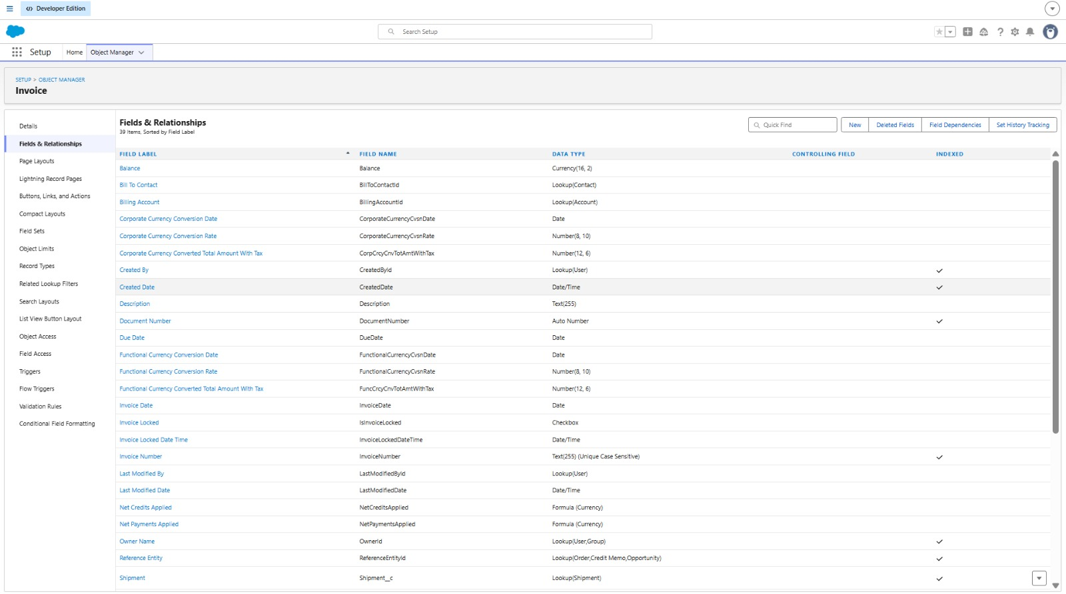
Evidence / Screenshot

7. Important Note
The fields and relationships above are recommended for the Courier Management System project. If your Salesforce org already contains fields with different API names, keep the existing working names and update this document to match them. Mark implementation as complete only after creating and testing the fields in Salesforce.

